**Experiment no 7**

**Name:** Shaikh Masood Iqbal

**Roll No.:** 24DDS02

**AIM:** To design and simulate the environment for Dynamic routing using Cisco packet tracer.

**REQUIREMENTS:** CISCO Packet Tracer

**THEORY:**

#### Dynamic Routing:

**Dynamic routing** is known as a technique of finding the best path for the data to travel over a network in this process a router can transmit data through various different routes and reach its destination on the basis of conditions at that time of communication circuits.

Dynamic routers are smart enough to take the best path for data based on the condition of the present scenario at that time of the network. In case one section fails in the network to transfer data forward dynamic router will use its algorithm (in which they use routing protocols to gather and share information of the current path among them) and it will re- route the previous network over another network in real-time. And this amazing capability and functionality to change paths in real-time over the network by sharing status among them is the key functionality of Dynamic Routing. [OSPF](https://www.geeksforgeeks.org/open-shortest-path-first-ospf-protocol-fundamentals/) (open shortest path first) and [RIP](https://www.geeksforgeeks.org/routing-information-protocol-rip/) are some protocols used for dynamic routing.

#### Source code or Procedure:

**Step 1:** First, open the Cisco packet tracer desktop and select the devices given below:

|  |  |  |  |
| --- | --- | --- | --- |
| **S.NO** | **Device** | **Model Name** | **Qty.** |
| **1.** | PC | PC | 6 |
| **2.** | Switch | PT-Switch | 3 |
| **3.** | Router | PT-router | 3 |

**IP Addressing Table:**

|  |  |  |  |  |
| --- | --- | --- | --- | --- |
| **S.NO** | **Device** | **IPv4 Address** | **Subnet mask** | **Default Gateway** |
| **1.** | PC0 | 192.168.10.2 | 255.255.255.0 | 192.168.10.1 |
| **2.** | PC1 | 192.168.10.3 | 255.255.255.0 | 192.168.10.1 |
| **3.** | PC2 | 192.168.20.2 | 255.255.255.0 | 192.168.20.1 |
| **4.** | PC3 | 192.168.20.3 | 255.255.255.0 | 192.168.20.1 |
| **5.** | PC4 | 192.168.30.2 | 255.255.255.0 | 192.168.30.1 |
| **6.** | PC5 | 192.168.30.3 | 255.255.255.0 | 192.168.30.1 |

* Then, create a network topology as shown below the image.
* Use an Automatic connecting cable to connect the devices with others.

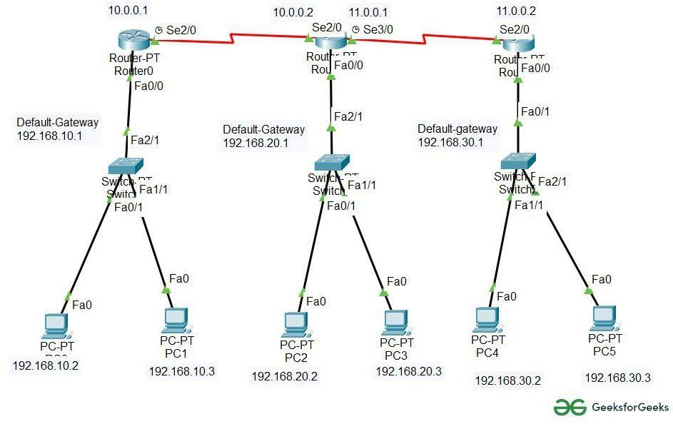

**Step 2:** Configure the PCs (hosts) with IPv4 address and Subnet Mask according to the IP addressing table given above.

* + To assign an IP address in PC0, click on PC0.
  + Then, go to desktop and then IP configuration and there you will IPv4 configuration.
  + Fill IPv4 address and subnet mask.

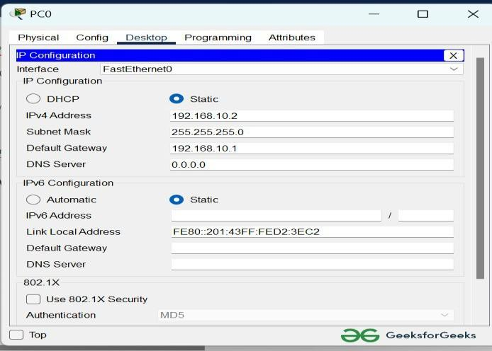

* + Repeat the same procedure with other PCs to configure them thoroughly.

**Step 3:** Configure router with IP address and Subnet mask.

#### IP Addressing Table Router:

|  |  |  |  |  |
| --- | --- | --- | --- | --- |
| **S.NO** | **Device** | **Interface** | **IPv4 Address** | **Subnet mask** |
| **1.** | router0 | FastEthernet0/0 | 192.168.10.1 | 255.255.255.0 |
| Serial2/0 | 10.0.0.1 | 255.0.0.0 |
| **2.** | router1 | FastEthernet0/0 | 192.168.20.1 | 255.255.255.0 |
| Serial2/0 | 10.0.0.2 | 255.0.0.0 |
| Serial3/0 | 11.0.0.1 | 255.0.0.0 |
| **3.** | router2 | FastEthernet0/0 | 192.168.30.1 | 255.255.255.0 |
| Serial2/0 | 11.0.0.2 | 255.0.0.0 |

* + To assign an IP address in router0, click on router0.
  + Then, go to config and then Interfaces.
  + Make sure to turn on the ports.
  + Then, configure the IP address in FastEthernet and serial ports according to IP addressing Table.
  + Fill IPv4 address and subnet mask.

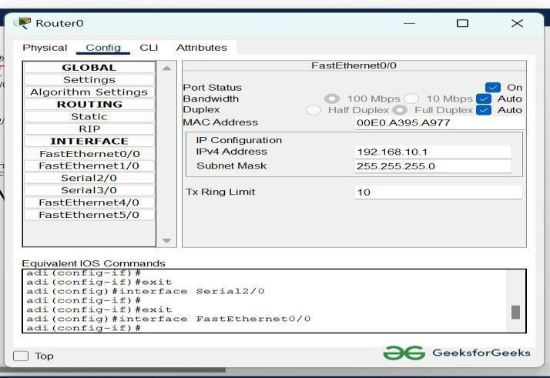

* Repeat the same procedure with other routers to configure them thoroughly.

**Step 4:** After configuring all of the devices we need to assign the routes to the routers. To assign RIP routes to the particular router:

* + First, click on router0 then Go to CLI.
  + Then type the commands and IP information given below.

CLI command : network <network id> RIP Routes for Router0 are given below:

Router(config)#network 192.168.10.0

Router(config)#network 10.0.0.0

RIP Routes for Router1 are given below:

Router(config)#network 192.168.20.0

Router(config)#network 10.0.0.0

Router(config)#network 11.0.0.0

RIP Routes for Router2 are given below:

Router(config)#network 192.168.30.0

Router(config)#network 11.0.0.0

**Step 5:** Verifying the network by pinging the IP address of any PC.

* + We will use the ping command to do so.
  + First, click on PC0 then Go to the command prompt.
  + Then type ping <IP address of targeted node>.
  + As we can see in the below image we are getting replies which means the connection is working properly.

Example: ping 192.168.20.2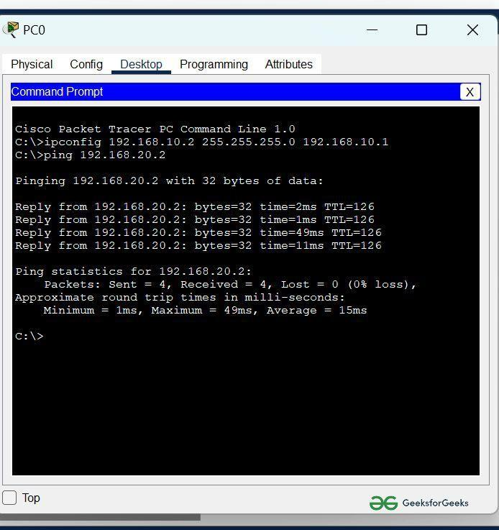

* A simulation of the experiment is given below we are sending PDU from PC0 to PC2 and PC3 to PC5:

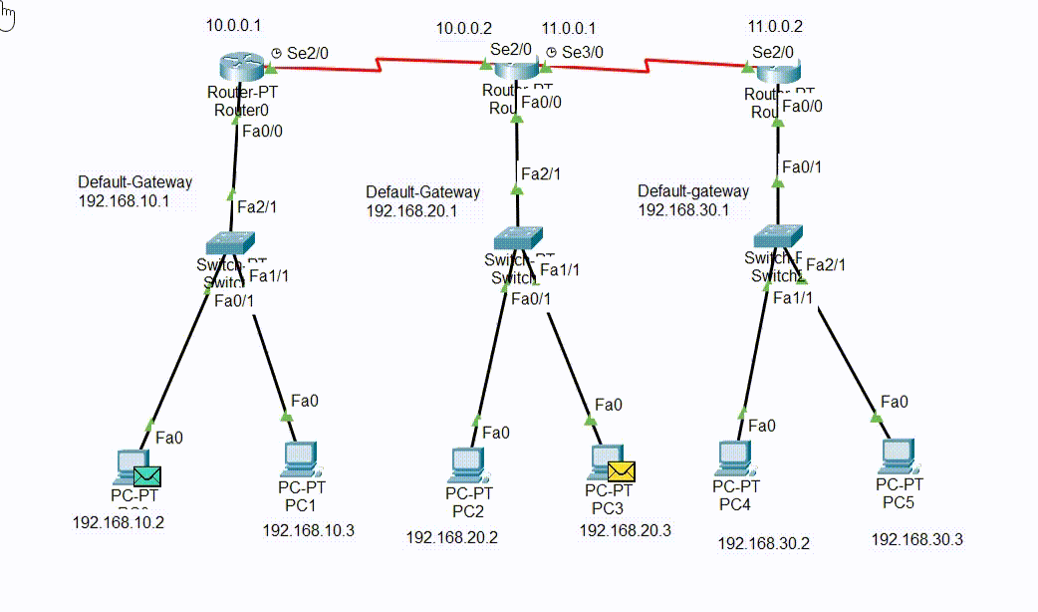

**MY OUTPUT:**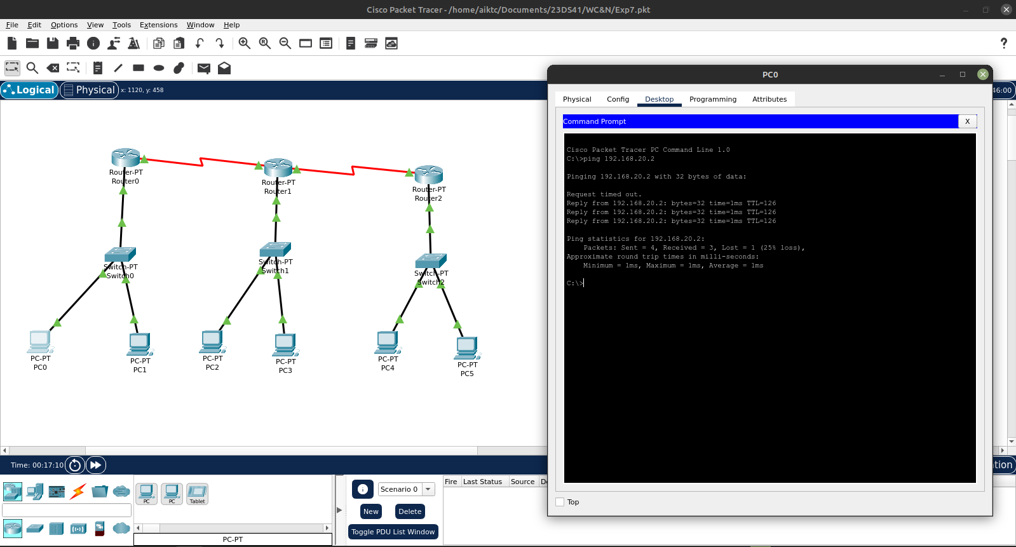

**CONCLUSION:** We have Design and simulate the environment for Dynamic routing using Cisco packet tracer.